• ZERO MAINTENANCE • ZERO HASSLES • MAXIMUM ELECTRIC POWER

# BW Lithium batteries

**OWNER MANUAL**

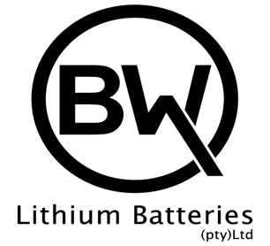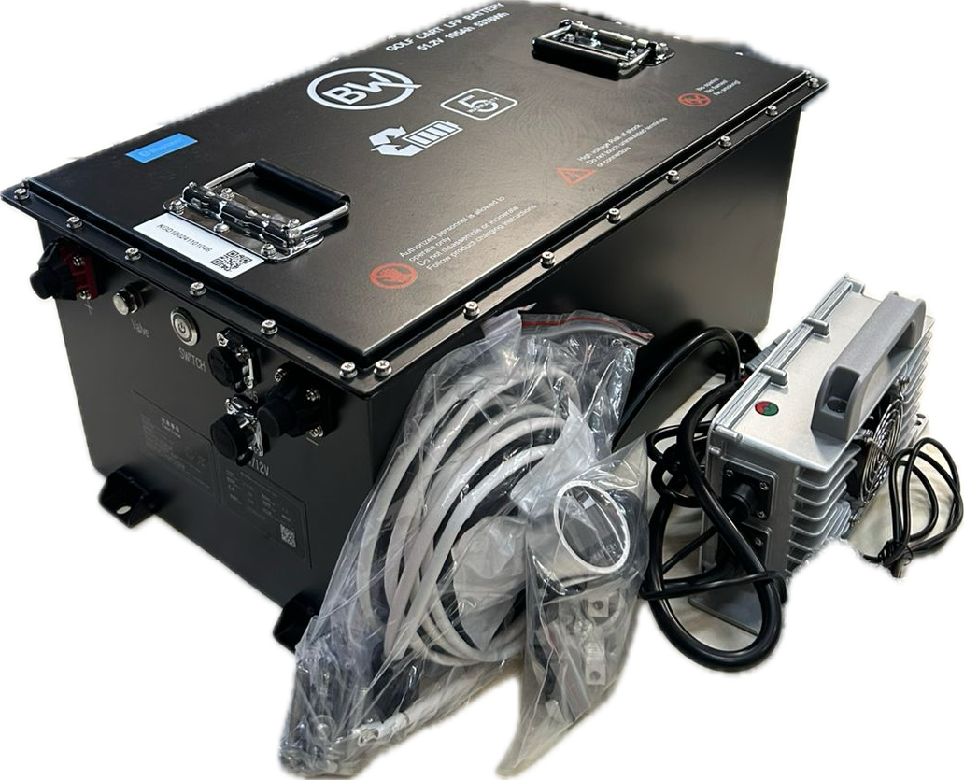

**APPLICATIONS**

Foreword

Thank you for choosing BW Lithium batteries. This manual contains important information that you will need for the proper operation and handling of your BW Lithium battery. Please read this manual carefully before starting off with your new battery.

Please check the Lithium battery pack:

* Whether the model is correct,
* the appearance is intact,
* whether the vehicle voltage and charger are matched etc. to ensure the best performance of the battery. Please take note that the factory current of the battery is only 60% - make sure to fully charge it before first time use.

Overview

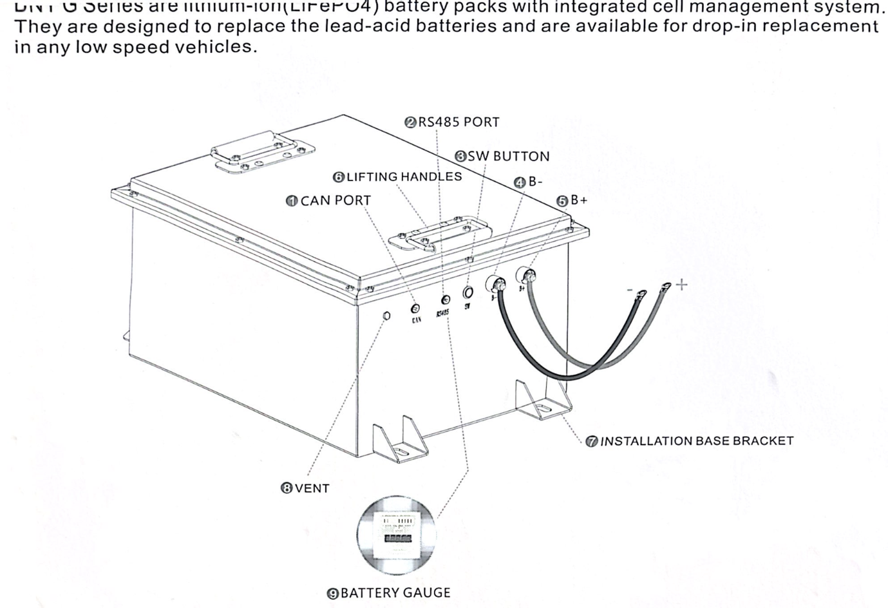BW Lithium batteries are Lithium-ion (LifePO4) battery packs with an integrated cell management system. These batteries are designed to replace lead-acid batteries and are available for drop-in replacements in any low speed vehicles.

|  |  |
| --- | --- |
|  | Can Port: Connector Port for Charger and BMS Programmer |
|  | RS485: Connector port for Lithium battery Gauge |
|  | SW: Inspection light and button for BMS |
|  | B - : Battery Negative Terminal |
|  | B+ : Battery Positive Terminal |
|  | Lifting handles for Lithium battery |
|  | Installation base brackets |
|  | Vent valve for Lithium-ion battery pack |
|  | Lithium battery Gauge |

Delivery items

* Battery pack
* Charger
* Battery gauge
* Receptable
* Can Cable
* Battery gauge cable
* Owner manual
* Optional installation adaptive brackets

BW LITHIUM BATTERY SYSTEM OVERVIEW

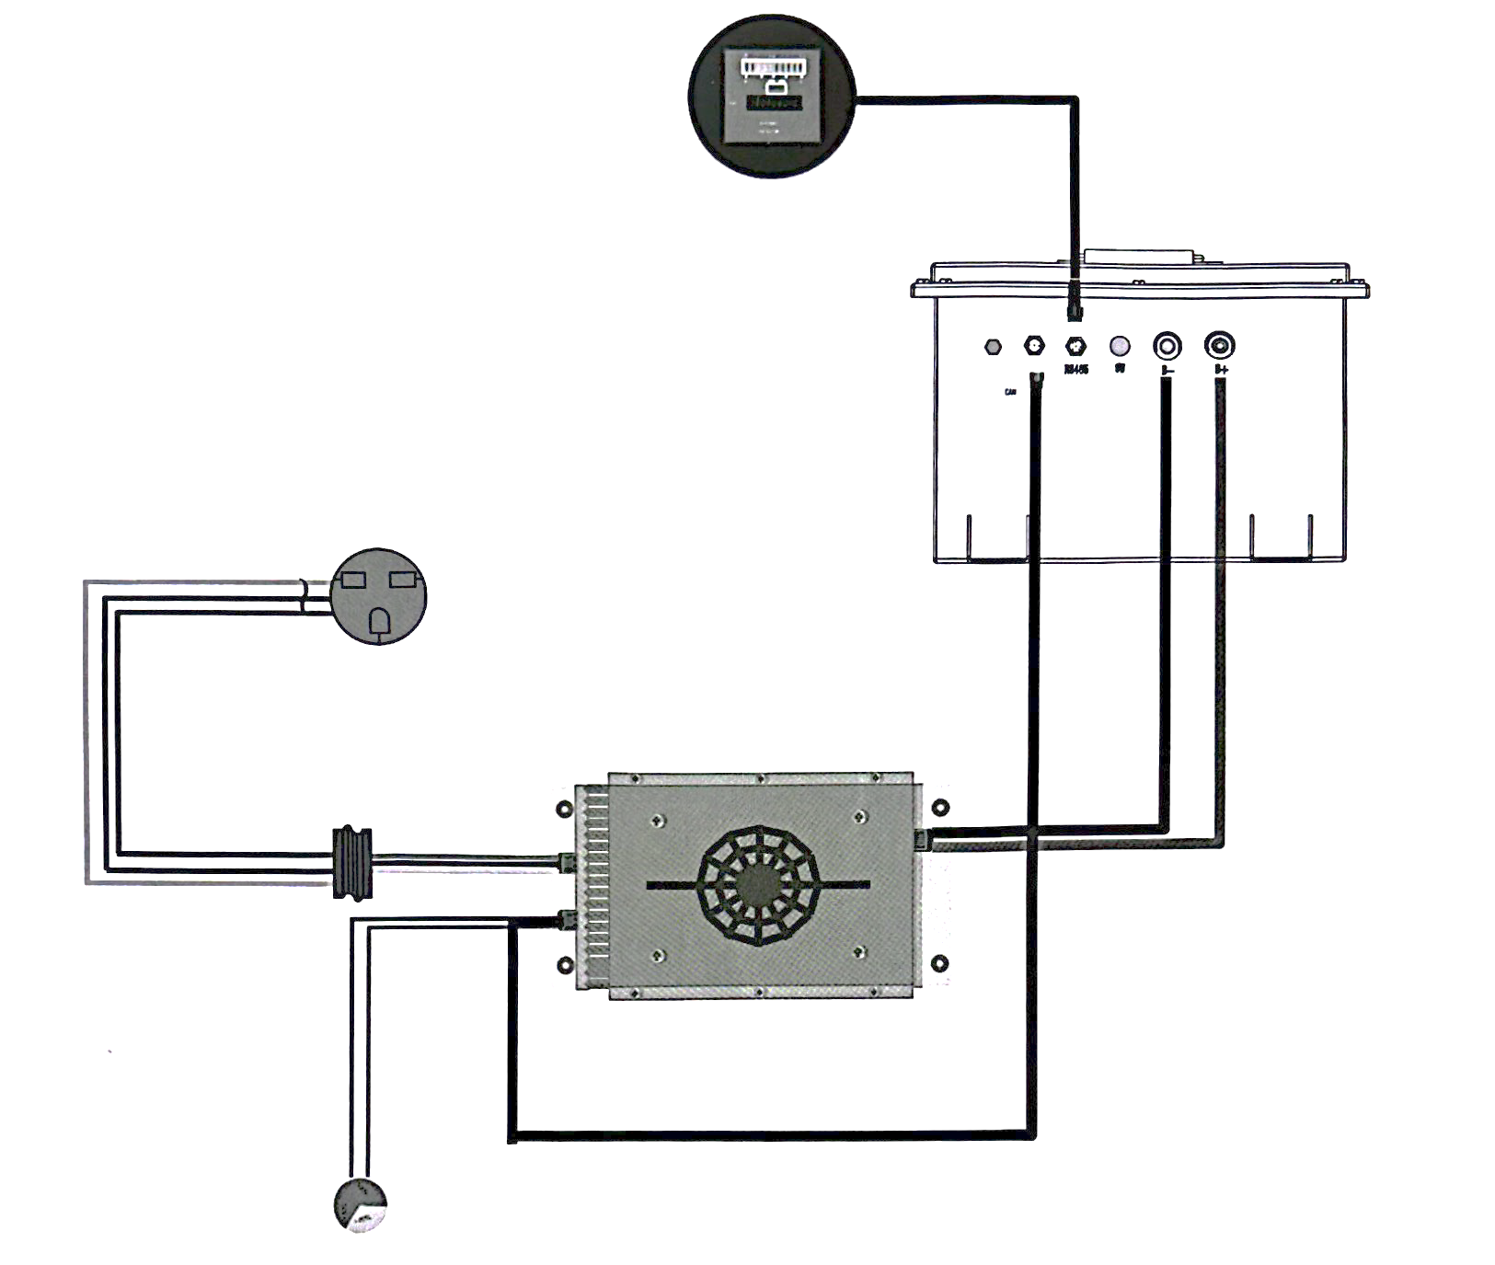

Battery Gauge

Battery Pack

22/110V AC Power cord

Receptacle

Charger output

Charger

Charger indicator

BW LITHIUM BATTERY INSTALLATIONS

**Installation Prerequisites**

When installing the system avoid touching the battery terminal with direct hands or any metal object(s). BW Lithium batteries provides a safe source of electric energy when operated as designed. Potentially hazardous circumstances such as excessive heat or electrolyte leakage may occur under improper operating conditions, damage and misuse and abuse. The safety precautions and the warning message described in previous section must be observed. If any of the precautions are not fully understood or if there is any questions contact the customer service for guidance.

Make sure the battery installation vehicle meets the following conditions;

* The battery installation position is flat and level.
* There are no flammable or explosive materials nearby.
* The ambience is shady and cool. Keep the batteries away from heat and avoid direct sunlight.
* The temperature and humidity stays at a constant level.
* There is minimal dust and dirt in the area.
* There is no corrosive gases present, including ammonia and acid vapor.

**Installation Steps**

|  |
| --- |
| **Step 1.** |
| Set up the parking brake. Turn off the key switch and remove the key. |
| **Step 2. – Remove all additional components that won’t be needed** |
| * Remove the original lead-acid batteries pack and plastic battery trays. * Remove the original lead acid battery charger. * Remove the original battery meter and disconnect all wires attached to the lead-acid battery. |
| **Step 3. – Fasten the Lithium battery pack to the chasis** |
| Fasten the bracket into the compartment, put the battery pack inside and fasten the battery pack to the bracket. |
| **Step 4. – Install the charger and charger receptable** |
| * Fasten the charger to the vehicle. * Fasten the charger receptable to the vehicle. * Drill a hole nearby the receptable for installing the lithium battery charger status indicator * Connect all the connectors to the lithium battery charger * Connect the receptable plug to charge the input connector * Connect the CAN cable, to the one side of the charger and the other side to the port on the battery |
| **Step 5. – Install the Lithium battery gauge and connect the cables** |
| Connect the RS458 cable to the one side of the battery gauge and the other side to the port on the battery |
| **Step 6. – Connect the positive and negative charger cables** |
| Charger output cables to battery pack positive and negatives terminals. |
| **Step 7. – Test the cart and lithium battery** |
| * Check the tightening of the mounting bolts * Check the tightness of the terminals |

Battery storage

When the BW Lithium battery is stored for over one month, place the battery in a dry and ventilated room with the correct temperature ranging between 0 – 35 degrees. Make sure the battery is not stored near corrosive materials or fire or any type of heat source.

In order to avoid over discharge, the power must be turned off and the SOC must be kept above 60% to avoid over discharge. The battery must be left fully charged and be charged again every three months.

Battery operations

**Turn the battery on/off**

Make sure that the installation and wiring harness are correctly done. Press the SW button on the battery pack for 3 (three) seconds to power on and 8 (eight) seconds to power off.

**Monitoring**

For basic battery SOC (State of charge) information, check the battery level display module.

The mobile app can be used to monitor the battery via Bluetooth. Download and install the app: **KINGOR BW Battery.** Enter the login interface, account number and password to successfully login. (You can contact the sales person directly for the account number).

Through the mobile app you will be able to see the voltage of each cell, the battery temperature or be informed about any voltage/temperature alarms. Take note that alarm messages can only be seen or received when the app is actively connected to the battery and the phone is actively showing the lithium battery screen.

**Charging**

BW Lithium batteries uses a charge current of 20A. This means if the battery is completely empty it will take 2 -10 hours (depending on battery model) to recharge. The maximum charge current is 1C. This will charge the battery in an hour. Take note that the batteries will produce more heat when high charge currents are used and may result in the need for more ventilation space as well as hot air extraction or forced air cooling.

The battery needs to be charged with the designated charger that BW Lithium batteries provide otherwise it may cause insufficient charging or battery damages. In this case BW Lithium batteries will not be responsible for any problems caused by this matter.

Safety warnings

Warranty Statement

**5 year limited warranty**

BW Lithium Batteries (“Manufacturer”) warranty each Lithium Golf Branded Pack (“Product”) consisting of BW Lithium branded components; LiFePO4 Battery/Batteries, LiFePO4 Battery Charger and LiFePO4 Battery Meter sold by Authorised Dealers in South Africa to be free of defects in material and workmanship for a period (the “Warranty Period”) based upon the Product use application.

**Warranty period**

* Private Golf Use — 5 YEARS for Private Golf customers, using the Product for their own Personal golfing. Commercial and Non-Golf Use — 3 YEARS for Commercial and Non-Golf customers using the Product for Commercial or purposes outside of Golf. "is includes using the Product as part of Business Operations, including renting Golf Carts to customers, using the vehicle for a purpose other than Golf, including as transport on private or public areas.
* For the accessories such as chargers, cables, etc., from the date of purchase, one year is provided for the warranty service.
* Warranty period may vary by country and is subject to local laws and regulations.

**Non-transferable**

This Warranty applies only to the original end-user/owner of the Product and is not transferable to any other person or entity. Contact the place of purchase regarding any warranty claim.

**Warranty statement**

Distributors are responsible for the service to customers. Free parts and technical support are provided by BW Lithium batteries to our distributors.

BW Lithium batteries provide warranty under the following conditions:

* The product is within the specified warranty period
* The product is normally used, without man-made quality problems.
* No unauthorised disassembly, maintenance etc.
* Product serial number, factory label and other marks are not torn or altered.

**Warranty exclusions**

Manufacturer provides Warranty on Products only and will not be held responsible for any damage to the Product or vehicle as a result of incorrect installation, abuse or neglect. Examples include but are not limited to:

* Products exceed the warranty period without purchasing a warranty extension.
* Damage caused by human abuse, including but not limited to cover deformation, collision caused by impact, drop, and puncture.
* Dismantle the battery without BW Lithium batteries authorization;
* Failure to work or being torn down in a harsh environment with high temperature, humidity, dust, corrosives and explosives, etc;
* Damage caused by short circuit;
* Damage caused by an unqualified charger that is not compliant with the product manual;
* Damage caused by force majeure, such as fire, earthquake, flood, hurricane, etc;
* Damage caused by improper installation not compliant with the product manual;
* Product without BW Lithium batteries trademark or serial number.
* Using components that have not been approved by the Manufacturer as replacement components to those which are supplied in the Manufacturer’s original Product pack;
* Failure to properly store the Product. This includes not disconnecting product from any items that may draw power;
* Damage caused during shipping or mishandling of the product;
* Using the Product for any purpose outside it's intended design;
* Incorrect voltage applied to application

**Claim procedure**

Warranty claims are to be made only by an Authorised Dealer or the end-user/owner of the Product. When submitting a Warranty claim the customer may be required to provide relevant information to support the Warranty claim, including but not limited to:

* Original receipt for purchase
* Photos or video evidence of the failure
* Returning Product to Authorised Dealer or Manufacturer.

All requests must start by either contacting the Authorised Dealer from where Product was purchased. The request will be reviewed and responded to with the necessary technical assistance.

If technical assistance does not resolve the issue and the claim is seemingly covered under warranty, the Manufacturer will send approval for the product be sent to the Manufacturer at the expense of the end-user/owner of the Product.

The Manufacturer will test the Product and determine if the product was affected by the above defects or damage to the Product arising from any abuse or mishandling of the Product. See list of noncovered conditions located above (4. Warranty Exclusions).

Warranties are for repair, replacement, or substitution only, in Manufacturer’s sole discretion. Refunds are not available.

**Remedy**

If a device becomes defective during the warranty period recognized by BW Lithium Batteries. BW Lithium or its local authorized service partner is obligated to provide service to customer, the device will be subject to our option below:

* repaired on-site, or
* repaired by BW Lithium batteries service center, or
* swapped for a replacement device with equivalent specifications according to model and service life.

In the third case the replaced device will inherit the remaining warranty period of the previous device. In this case, you do not receive a new warranty card since your warranty right is recorded in BW Lithium batteries service database.

If you would like to purchase an extension of BW Lithium batteries warranty based on the standard warranty, please contact BW Lithium batteries to get the detailed information.

**Warranty disclaimer**

This warranty is in lieu of, and Manufacturer disclaims and excludes, all other express warranties. Manufacturer further limits the duration of all, whether statutory, express or implied warranties, including, without limitation, any warranty of merchantability or fitness for a particular purpose, to the Warranty Period.

Manufacturer’s exclusive liability for breach of any warranty on the Product shall be to replace the Product within the Warranty Period in accordance with the terms of this warranty. In no event shall the Manufacturer be liable for any loss or damages of any other kind, whether direct, incidental, and consequential including lost profits, labour cost, exemplary, special or otherwise, including any lost profits or removal, shipping, labour cost, or installation expenses.