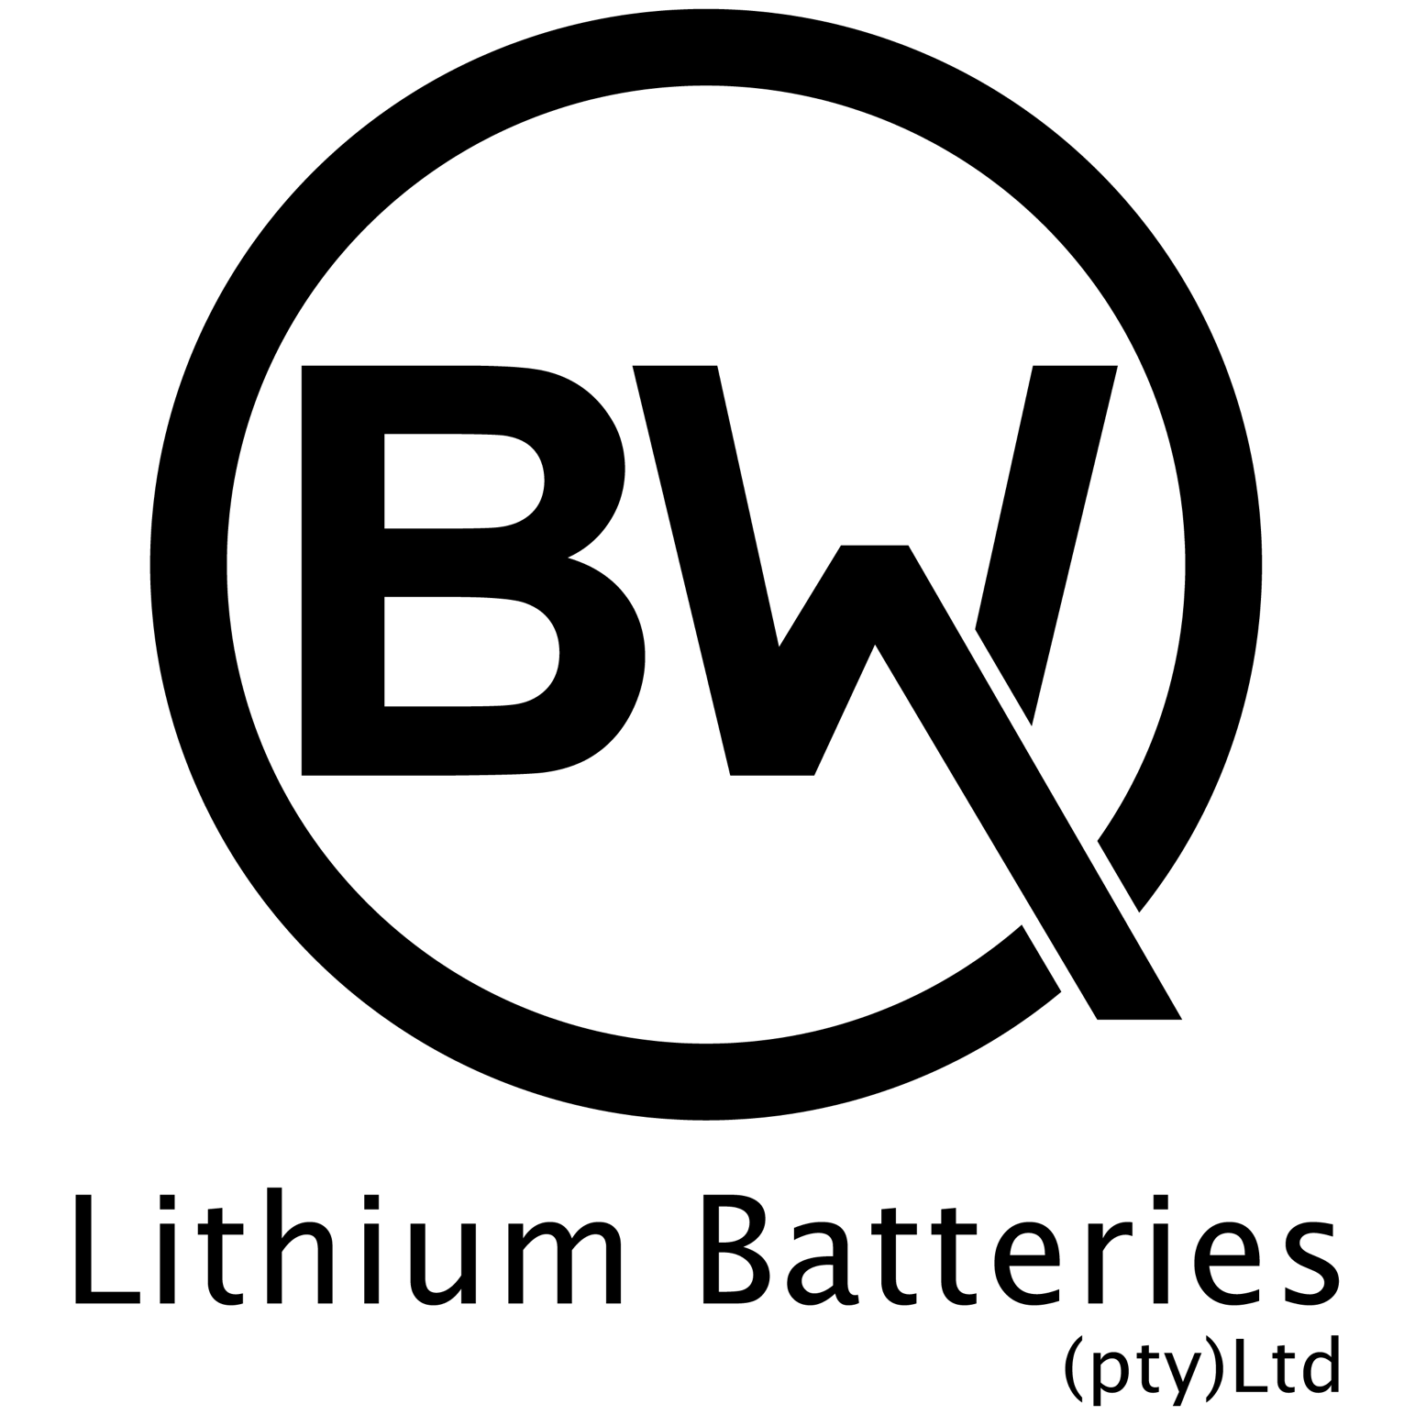

BW Lithium Batteries (“Manufacturer”) warrants each Lithium Golf Branded Pack (“Product”) consisting of BW Lithium branded components: LiFePO4 Battery/Batteries, LiFePO4 Battery Charger and LiFePO4 Battery Meter sold by Authorised Dealers in South Africa to be free of defects in both material and workmanship for a period (the “Warranty Period”) based upon the Product use application.

1. **WARRANTY PERIOD**

* Private Golf Use — **5 (five) YEARS** for Private Golf customers, using the Product for their own Personal golfing.
* Commercial and Non-Golf Use — 5 (five) YEARS for Commercial and Non-Golf customers using the Product for commercial or purposes outside of Golf. This includes using the Product as part of business operations, renting Golf Carts to customers, using the vehicle for purposes other than Golf, such as transport on private or public areas.
* For accessories such as chargers, cables, etc., from the date of purchase, 1 (one) YEAR is provided for the warranty service.
* Warranty period may vary by country and is subject to local laws and regulations.

1. **NON-TRANSFERABLE**

This Warranty applies only to the original end-user/owner of the Product and is not transferable to any other person or entity.

1. **WARRANTY STATEMENT**

Distributors are responsible for the service to customers. Free parts and technical support are provided by BW Lithium batteries to our distributors.

BW Lithium batteries provide the warranty under the following conditions:

* The Product is within the specified warranty period
* The Product is used within the technical parameters and specifications
* No unauthorised disassembly, maintenance, etc.
* Product serial number, factory label and other marks are not torn or altered.
* The Product has been installed correctly in accordance with the manufacturer’s installation manual and instructions.
* The Product has not been altered or tampered with in any way.

1. **WARRANTY EXCLUSIONS**

Manufacturer provides Warranty on Products only and will not be held responsible for any damage to the Product or vehicle resulting from incorrect installation, abuse or neglect. Examples included but are not limited to:

* Products exceed the warranty period without purchasing a warranty extension.
* Damage caused by human abuse, including but not limited to cover deformation, collision caused by impact, drop, and puncture.
* Dismantling the battery without BW Lithium batteries written authorisation.
* Failure to work or being operated in a harsh environment with high temperature, humidity, dust, corrosives and explosives, or similar.
* Damage caused through short circuit.
* Damage caused by an unqualified charger that is not compliant with the product manual.
* Damage caused by force majeure, such as fire, earthquake, flood, hurricane, etc.
* Damage caused by improper installation not compliant with the product manual.
* Product without BW Lithium batteries trademark or serial number.
* Using components that have not been approved by the Manufacturer as replacement components to those which are supplied in the Manufacturer’s original Product pack.
* Failure to correctly store the Product. This includes not disconnecting product from any items that may draw power.
* Damage due to mishandling of the product during transport and installation.
* Using the Product for any purpose outside it's intended design and application.
* Incorrect voltage applied to application.

1. **CLAIM PROCEDURE**

Warranty claims are to be made only by an Authorised Dealer or the end-user/owner of the Product. When submitting a Warranty claim the customer may be required to provide relevant information to support the Warranty claim, including but not limited to:

* Original receipt for purchase
* Photos or video evidence of the failure
* Returning the Product to Authorised Dealer or Manufacturer

All requests must be initiated by contacting the Authorised Dealer from where Product was purchased. The request will be reviewed and responded to with the necessary technical assistance.

If technical assistance does not resolve the issue and the claim is seemingly covered under warranty through inspection by the Authorised Dealer, the Manufacturer will send approval for the Product to be sent to the Manufacturer at the expense of BW Lithium Batteries.

The Authorised Dealer will provide the user with a replacement unit, until such time as the Warranty Claim is resolved.

The Manufacturer will test the Product and determine whether the product was affected by the above defects or damage due to the Product arising from any abuse or mishandling of the Product. See list of noncovered conditions located above (4. Warranty Exclusions).

If the Warranty claim is approved, then the user will keep the replacement unit and no cost.

If, however, the Warranty claim is rejected for any reasons as listed under (4. Warranty Exclusions), the user will be charged for the replacement unit by the Authorised Dealer.

Warranties are for repair, replacement, or substitution only, at Manufacturer’s sole discretion. Refunds are not available.

1. **Remedy**

If a device becomes defective during the warranty period recognised by BW Lithium Batteries. BW Lithium or its local Authorised Dealer is obligated to provide service to the customer. The device will be subject to one of the following options:

* repaired on-site, or
* repaired by BW Lithium batteries service centre, or
* swapped for a replacement unit with equivalent specifications according to model and service life.

In the third case the replaced device will inherit the remaining warranty period of the previous device. In this case, the user does not receive a new warranty card since the existing warranty right is recorded in BW Lithium batteries service database.

If the user would like to purchase an extension of BW Lithium batteries Warranty based on the standard warranty, please contact BW Lithium batteries to get the detailed information.

1. **WARRANTY DISCLAIMER**

This warranty is in lieu of, and Manufacturer disclaims and excludes, all other express warranties. Manufacturer further limits the duration of all, whether statutory, express or implied warranties, including, without limitation, any warranty of merchantability or fitness for a particular purpose, to the Warranty Period.

Manufacturer’s exclusive liability for breach of any warranty on the Product shall be to replace the Product within the Warranty Period in accordance with the terms of this warranty. In no event shall the Manufacturer be liable for any loss or damages of any other kind, whether direct, incidental, and consequential including lost profits, labour cost, exemplary, special or otherwise, including shipping, labour cost, or installation expenses.